|  |  |
| --- | --- |
| Course name:  Diploma in Software and Design | |
| Assignment title | **DSD-04 Agile Group Project** |
| Assessment weighting | *Need to pass the assessment to complete the course* |
| Passing Criteria: | Need to score 50% or more to pass the assessment.  **Total Marks: 100** |
| Due date: | **Your Tutor will advise you**  (late submissions incur 10% penalty, after 7 days late, the assessment will not be marked) |
| Assessment conditions: | This is a resource-based assessment. This means that you may have access to any relevant resources to assist you.  This could include your learning materials, information on the Internet, and so on. However, all work must be your own with no assistance from any other person. |
| Submission requirements: | Upload your project to Github or Cloud Campus |
| Module Names and Learning Outcomes | **Project Management**   * 1. Identify requirements and implement mobile solutions * 2. Conduct project planning activities that accurately forecast project costs, timelines, and quality. Implement processes for successful resource, communication, and risk and change management. * 3. Use an appropriate methodology for project management * 4. Demonstrate effective project execution and control techniques that result in successful projects * 5. Satisfy client expectations and meet client needs in executing a software development project |

This is an **ONLINE** only assessment. No paperwork is needed.

**Disclaimer of Plagiarism and Collusion**

I declare that:

* I have read and understood the ATC Vision Collage “Assessment Policy” and “Academic Cheating” sections as described in the Student Handbook.
* I am aware of the penalties for cheating as described in the Student Handbook.
* This assessment submission is entirely my own work, I have quoted, referenced and acknowledged any work copied directly from another source.
* I understand this assessment submission may be used for internal and/or external moderation.

I understand that if I have circumstances that affect my progress to complete assessment tasks, I will discuss it with my tutor prior to submission date

# Agile Group Project

## Objective

The students are required to undertake a group project as part of their Assessment for the Diploma in Software Engineering and Design qualification. The students are required to build an Android app using Agile methodologies. The App will also use a Source Control system such as Git.

## Purpose

The purpose of the assessment is to create an Android App using Agile and Scrum methodologies.

The intention is that all group projects should be successful, and all students are expected to contribute to their own project in accordance with the timetable.

Group projects are expected to take students 180 hours of work per student, spread over 6 to 7 weeks, and to enable students to display their understanding across a broad range of subjects.

Groups will be expected to exhibit professional skills in design, quality and management. Specifically, they will have to show that the work has been carefully planned, that components and systems have been properly tested, and that members of the group have cooperated effectively.

The exercise also gives students experience of working against deadlines, with a team of colleagues. This gives some idea of the problems encountered in normal professional practice.

The review meetings provide an opportunity to monitor group progress and for general discussion. Your tutor will attend all the review meetings.

### Requirements

Create a mobile app using Agile and Scrum methodologies. The final app may not be totally finished owing to time constraints. But still be operatable.

## Final deliverables

Copy and paste the questions below into a new document, answer them, and put it in your assessment folder with a copy of the app.

**Answer the following questions.**

What was the App that your group created?

**Answer:**

We created an Expense App.

### Agile / Scrum

1. What did you learn about how the Agile and Scrum methodologies operate?

**Answer:**

The **Agile methodology** operates using continuous requirements. In agile the requirements of the user changes time to time and the develop has to make iterations accordingly.

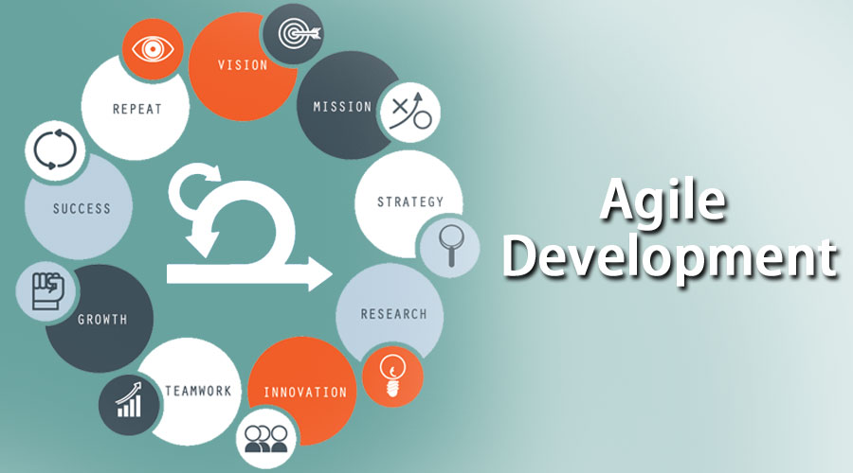

In **Scrum methodology** there is proper planning of the project is done before every functionality implementation in the starting and the project is divided in to different sprints each sprint is achieving one of the planned functionalities of the project. Each sprint is planned in a team meeting in the start of the sprint and a backlog is created on which all the members will operate.

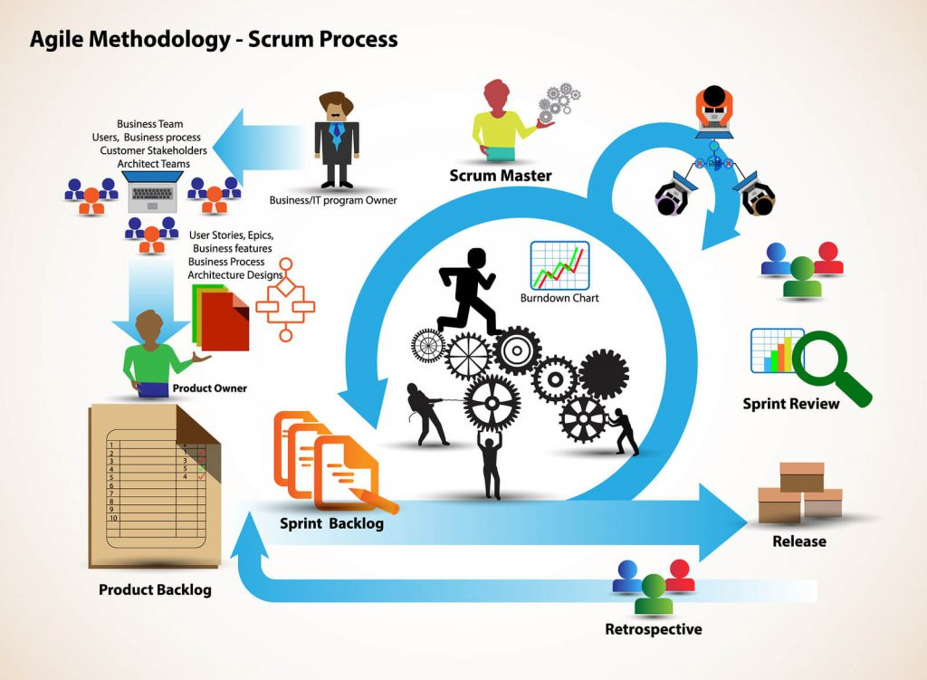

1. In practice how effective did you find this methodology?

**Answer:**

Both the methodologies have their own importance based on the requirement of the user if the user is unclear about what he exactly wants then the agile methodology must be used.

1. What did you find was the strength of it?

**Answer:**

I found that the agile methodology is more flexible, transparent, productive and the stakeholders are more satisfied and flexible with this methodology as every thing is in their knowledge and according to their needs and demands.

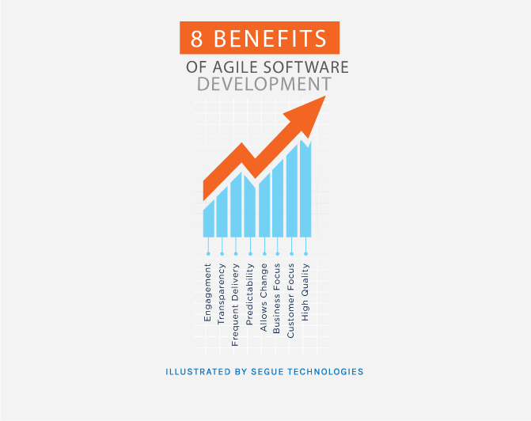

1. What were its weaknesses?

**Answer:**

The weaknesses I identified during this group project is that there is no finite end of the requirements in the agile methodology requirements are always creeping towards the developer. Documentation is limited as it lacks advance planning and the output in this methodology is mostly fragmented.

1. What were the best features of the process?

**Answer:**

The features of agile methodology that are best according to me are stated as follows:

* Flexibility due to agility.
* Transparency of the project due to agility.
* Productivity of the agile methodology.

1. How did they appeal to you?

**Answer:**

These features appeal me as they make my client more comfortable with the work as these features help to involve the client in all the development process of the app. And helps in achieving the client’s satisfaction.

1. What was the worst feature of the process?

**Answer:**

The worst feature I found in this process is the always creeping requirements from the client side. As new requirements and changes are always, there that makes the development time infinite.

1. How would you change them?

**Answer:**

I think we can make a brain storming session with the client before the beginning of any functionality of the app that will help reducing the creepy requirements.

### Group work

1. What did you enjoy about this style of programming?

**Answer:**

I enjoyed the collaboration of the client with the project as all the functionalities and the project progress is visible to the client and the developer that help improving the understanding between both the parties.

1. What are the downsides for you of group work?

**Answer:**

I found that while working in the group with the agile methodology always disturbs the group’s planning for the development of the methodology.



1. How did this session change your opinion of working in industry?

**Answer:**

This session changed my mind set as I come to know that working in a practical environment has some technical and complex matters that has to be treated appropriately as the client is involved working in the industry is not as simple as doing a college project.

### Source Control

1. What form of Source Control did you use?

**Answer:**

We used GitHub as source control for the sake of version control of our application.



1. What were its strengths?

**Answer:**

The strengths for using GitHub are stated as follows:

* It makes it easy to contribute to the open-source project.
* Work can be show cased using GitHub.
* Changes can be easily tracked.
* We have integration options with other platforms on GitHub.

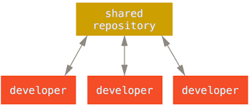

1. What were its weaknesses?

**Answer:**

The weaknesses for using GitHub are stated as follows:

* Security and pricing of the GitHub are the weaknesses of this source control platform.

1. How effective as a source control did you find it?

**Answer:**

I found this methodology very effective as this helps in managing the app versions efficiently and can easily be integrated with any cloud.

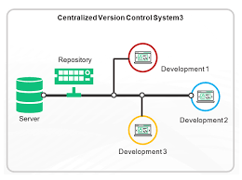

1. If you had to use it again what would you change?

**Answer:**

I’ll improve its security. As it’s the most common drawback of using GitHub.

### Other

1. Do you feel that this has been a worthwhile experiment?

**Answer:**

Yes.

1. Why? Why not?

**Answer:**

I found it a worth while experiment as it let is gain practical experience of the agile software development life cycle.

1. **If you had to give yourself a percent grade for your contribution to the project, and the process, what would it be?** Bearing in mind that you might have produced little, yet done the hard yards. Or you made heaps, but it was really easy.

**Answer:**

I would give me an **A** because even the work I show cased is little but the effort behind that little output is massive.